03 Aug 2020  
 Version: 1.0

**DESIGN VERIFICATION REPORT**

Table of Contents

1. Introduction…………..……………………………………………………………………………………………..3
2. Power Supply Test………..……………………………………………………………………………………….3

2.1. Line Regulation Test……………………………………………………………………………………….3

2.2. Ripple voltage…………………………………………………………………………………………………4

1. Hall Sensor Test…………………………………………………………………………………………………….5

3.1. Hall sensor functionality…………………………………………………………………………………5

3.2. Functionality Test…………………………………………………………………………………………..6

1. Protection circuitry……………………………………………………………………………………………….7

4.1. Reverse Voltage Test……………………………………………………………………………………..7

4.2. Over voltage Test…………………………………………………………………………………………..8

1. **Introduction**

LMAT-AMT-V3 is gear shift lever PCB which uses Hall Effect sensor technology to detect the positions of gear. The detected positions of gear lever will be sent to TCU as per the voltage levels mentioned in the EE spec shared by client.

The block diagram of LMAT-AMT-V3 is shown below:

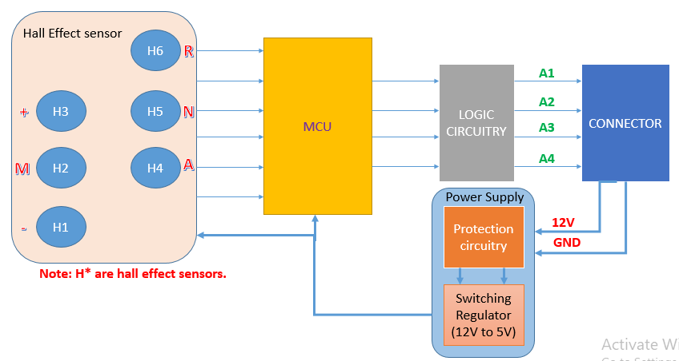

**Block Diagram**

1. **Power Supply Test**
   1. **Line Regulation Test**

This done is performed to check the ability of power supply to maintain constant output voltage despite changes to the input voltage with output current from power supply remaining constant.

* + 1. **Test setup**

AMT board is connected to RPS supply using the wiring harness connector and the input voltage is varied from 6V to 18V. During these variable voltages, the output is measured across the load.

* + 1. **Pass criteria**
* Output across the load should be 5V.
  + 1. **Observation Table**

**Load current = 500mA**

|  |  |  |
| --- | --- | --- |
| **Sl. No** | **Input Voltage (V)** | **Output voltage (V)** |
| **1** | **6** |  |
| **2** | **7** |  |
| **3** | **8** |  |
| **4** | **9** |  |
| **5** | **10** |  |
| **6** | **11** |  |
| **7** | **12** |  |
| **8** | **13** |  |
| **9** | **14** |  |
| **10** | **15** |  |
| **11** | **16** |  |
| **12** | **17** |  |
| **13** | **18** |  |

* 1. **. Ripple voltage**

This test is performed to check the ripple at the output voltage.

* + 1. **Test setup**

AMT board is connected to RPS supply using the wiring harness connector and the input voltage is varied from 6V to 18V. During these variable voltages, the ripple voltage is measured across C15.

* + 1. **Pass criteria**
* Ripple voltage should be as minimum has possible.
  + 1. **Observation**

|  |  |  |
| --- | --- | --- |
| **Sl. No** | **Input Voltage (V)** | **Ripple voltage (mV)** |
| **1** | **6** |  |
| **2** | **7** |  |
| **3** | **8** |  |
| **4** | **9** |  |
| **5** | **10** |  |
| **6** | **11** |  |
| **7** | **12** |  |
| **8** | **13** |  |
| **9** | **14** |  |
| **10** | **15** |  |
| **11** | **16** |  |
| **12** | **17** |  |
| **13** | **18** |  |

1. **Hall Sensor**
   1. **Hall sensor Functionality**

This test is performed to test the functionality of Hall Effect sensors.

* + 1. **Test setup**

AMT board is connected to RPS supply using the wiring harness connector and the input voltage is varied from 6V to 18V. During these variable voltages, the sensor output voltage is measured. U2, U4, U6, U3, U5 and U7 are the hall sensors

* + 1. **Pass criteria**
* Without placing the magnet, the Hall Effect sensor output should be high (5V). By placing the magnet, the output should be low (0V).
  + 1. **Observation**

|  |  |  |  |  |  |  |  |
| --- | --- | --- | --- | --- | --- | --- | --- |
| Input voltage (V) | 6 | 7 | 8 | 9 | 10 | 11 | 12 |
| Sensor Designator | Output voltage at each input voltage (V) | | | | | | |
| U2 |  |  |  |  |  |  |  |
| U4 |  |  |  |  |  |  |  |
| U6 |  |  |  |  |  |  |  |
| U3 |  |  |  |  |  |  |  |
| U5 |  |  |  |  |  |  |  |
| U7 |  |  |  |  |  |  |  |

|  |  |  |  |  |  |  |
| --- | --- | --- | --- | --- | --- | --- |
| Input voltage (V) | 13 | 14 | 15 | 16 | 17 | 18 |
| Sensor Designator | Output voltage at each input voltage (V) | | | | | |
| U2 |  |  |  |  |  |  |
| U4 |  |  |  |  |  |  |
| U6 |  |  |  |  |  |  |
| U3 |  |  |  |  |  |  |
| U5 |  |  |  |  |  |  |
| U7 |  |  |  |  |  |  |

* 1. **Functionality Test**

This test is performed to check the functionality of the GSL.

* + 1. **Test setup**

AMT board is connected to RPS supply using the wiring harness connector. The output lines A1, A2, A3 and A4 are connected to TCU and the voltage is measured across these lines after placing the magnet above each sensors.

* + 1. **Pass criteria**
* Voltage measured should be as per the below tabular column.

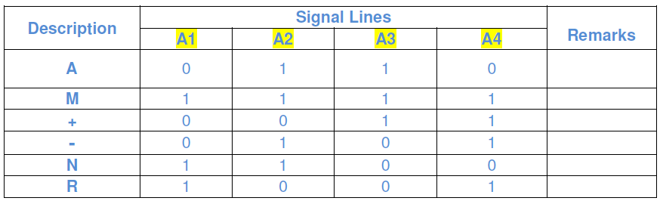

Table 1

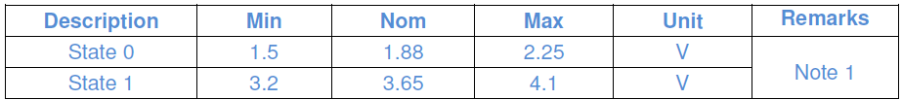

Table 2

* + 1. **Observation**
* Input voltage = 6V

|  |  |  |  |  |
| --- | --- | --- | --- | --- |
| **Magnet position** | **Voltage levels (V)** | | | |
|  | A1 | A2 | A3 | A4 |
| R |  |  |  |  |
| N |  |  |  |  |
| A |  |  |  |  |
| M+ |  |  |  |  |
| M |  |  |  |  |
| M- |  |  |  |  |

* Input voltage = 13.5V

|  |  |  |  |  |
| --- | --- | --- | --- | --- |
| **Magnet position** | **Voltage levels (V)** | | | |
|  | A1 | A2 | A3 | A4 |
| R |  |  |  |  |
| N |  |  |  |  |
| A |  |  |  |  |
| M+ |  |  |  |  |
| M |  |  |  |  |
| M- |  |  |  |  |

* Input voltage = 18V

|  |  |  |  |  |
| --- | --- | --- | --- | --- |
| **Magnet position** | **Voltage levels (V)** | | | |
|  | A1 | A2 | A3 | A4 |
| R |  |  |  |  |
| N |  |  |  |  |
| A |  |  |  |  |
| M+ |  |  |  |  |
| M |  |  |  |  |
| M- |  |  |  |  |

1. **Protection Circuitry**
   1. **Reverse voltage test**

This test is performed to check the functionality of the board after applying reverse voltage.

* + 1. **Test setup**

AMT board is connected to RPS supply in the reverse polarity using the wiring harness connector for 60s. After 60s, the output lines A1, A2, A3 and A4 are measured for each position.

* + 1. **Pass criteria**
* Board should be function properly after the reverse polarity test as per table 1 and 2.
  + 1. **Observation**

Input voltage = 13.5V

|  |  |  |  |  |
| --- | --- | --- | --- | --- |
| **Magnet position** | **Voltage levels (V)** | | | |
|  | A1 | A2 | A3 | A4 |
| R |  |  |  |  |
| N |  |  |  |  |
| A |  |  |  |  |
| M+ |  |  |  |  |
| M |  |  |  |  |
| M- |  |  |  |  |

* 1. **Over voltage test**

This test is performed to check the functionality of the board after applying over voltage.

* + 1. **Test setup**

AMT board is connected to RPS supply using the wiring harness connector and voltage is set to 20V for 60minutes. After 60 minutes, the output lines A1, A2, A3 and A4 are measured for each position.

* + 1. **Pass criteria**
* Board should be function properly after performing the overvoltage test as per table 1 and 2.
  + 1. **Observation**

Input voltage = 13.5V

|  |  |  |  |  |
| --- | --- | --- | --- | --- |
| **Magnet position** | **Voltage levels (V)** | | | |
|  | A1 | A2 | A3 | A4 |
| R |  |  |  |  |
| N |  |  |  |  |
| A |  |  |  |  |
| M+ |  |  |  |  |
| M |  |  |  |  |
| M- |  |  |  |  |